**Name**: Combination of Multiple Disabilities

**Description**:

As discussed earlier, under classification of multiple disabilities, the combinations could be considered in terms of number of disabilities present and nature of the combining disabilities. However, the more useful description of combination should take into view the –

* + - Impact the combining disabilities have on the individual, and
    - Implications for further rehabilitation efforts.

We shall further discuss one of the common combinations from this perspective.

*Figure 1:* Combination of multiple disabilities.

* + - **Polyhandicap**

It is a combination of multiple disabilities that includes intellectual disability. Challenges to intellectual capability may reduce an individual’s ability to make use of residual abilities in other –sensory-motor and socio-emotional domains, which may or may not be affected by presence of the disability. Hence, rehabilitation efforts have to be comprehensive in nature and catering to all-encompassing development of life skills, education and vocation.

* + - **Plurihandicap**

It is presence of multiple disabilities excluding intellectual disability. The delays, deviancies and/or disorders might primarily affect the sensory and physical-motor development and functioning. The rehabilitation intervention may focus on specific areas affected by the combined impact of these conditions.

* + - **Surhandicap**

It is a condition where combination of multiple disabilities displays secondary behavioural disorders that intervene the pre-existing disabilities. In such situation along with rehabilitation for primary conditions, supplementary intervention for managing and modifying behaviours also becomes vital.

**Name**: Associated Conditions

**Description**:

There are some additional ailments or disorders that are frequently found in children having multiple disabilities. These are called as associated conditions. In here, we shall discuss two such common associated conditions.

* + - **Epilepsy**

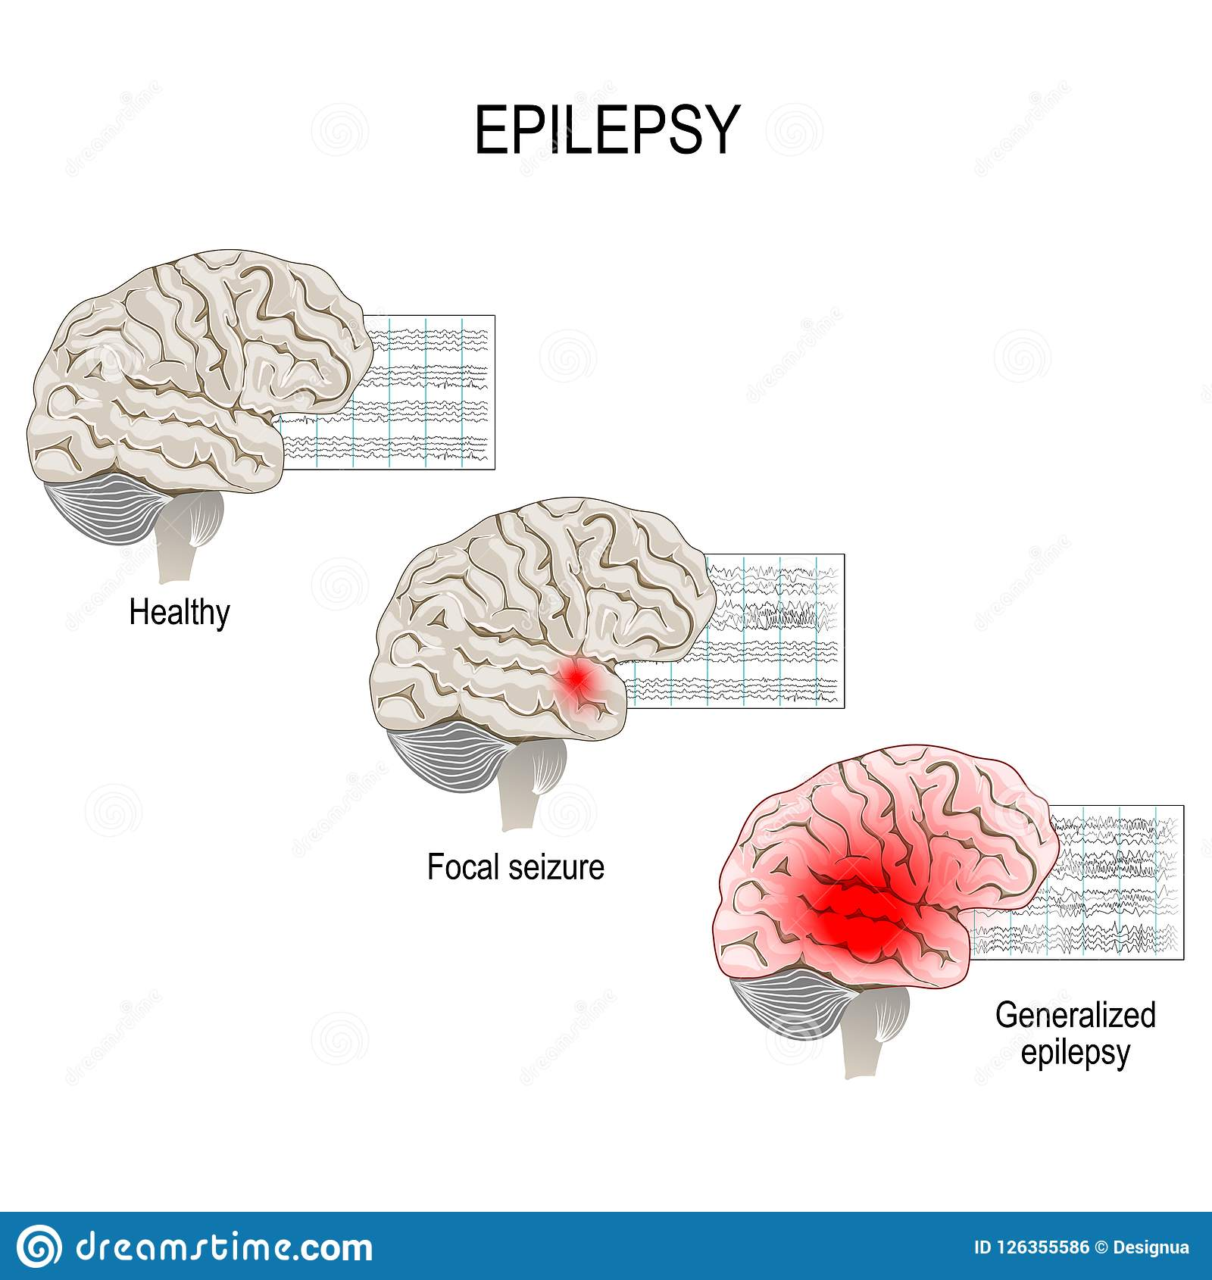One of the problems is epilepsy, which we also commonly call as fits. In simple terms it can described as abnormal or excessive cell activity in the brain causing seizures.

*Figure 2:* Abnormal cell activity in the brain.

Epilepsy can happen due to various reasons in children. Some of the common causes are brain injury, infectious diseases like meningitis, extremely high fever, etc. In adults some other reasons like stroke, excessive influence of alcohol, etc. Seizures may have unpleasant and even harmful effect on the individual affected on their consciousness, sensation, motor-movements and behaviours. There are two types of epilepsy – the tonic-clonic seizure and absence seizure. The ***tonic-clonic seizure*** is also known as the grand mal (which means big or greater illness) and might involve violent muscle contractions resulting in jerky movements of limbs and other body parts. The ***absence seizure*** is also at petit mal (meaning small or lesser illness) and might involve fleeting loss of consciousness accompanied by subtle changes in movements like eye-blinking, lip-smacking, etc.

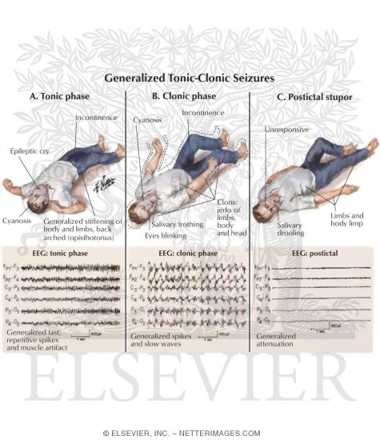

*Figure 3:* Tonic-Clonic Seizures.

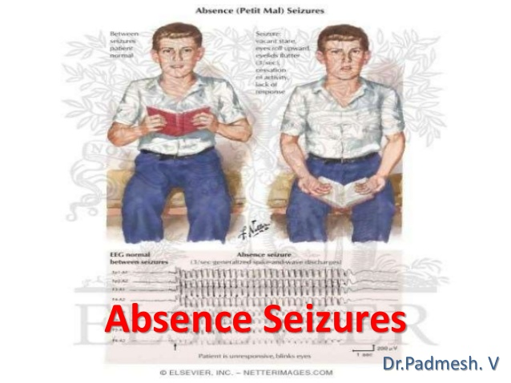

*Figure 4:* Absence Seizures.

If any children with or without disabilities is affected by epilepsy you may have to refer the parents to neurologist for further consultation and treatment. Treatment may include medication with helpful diet, and at times surgery also. If the tonic-clonic seizures occur in classroom environment, do not try to control the movements. Gently conduct to child to lying position with good ventilation around (and without crowding). Loosen the garments and ensure that jutting tongue doesn’t get caught between the teeth and the drooling saliva flows out. If the child looses consciousness, or if the condition persists for more than five minutes seek prompt medical aid. After recovery help child overcome feelings of embarrassment or fear. Absence seizures are very subtle with the symptoms going unnoticed often. However, if the fleeting loss of consciousness occurs in hazardous environments like near open fire, or during critical activities when child is handling sharp objects or climbing heights it might pose danger. Hence teachers should keep themselves informed of the possible symptoms and the necessary precautions to be taken.

* + - **Sensory Processing Disorders**

Another associated condition found in children with multiple disabilities is sensory processing disorders. Earlier known as Sensory Integration Dysfunction. Sensory processing disorders may again be categorised into three types of problems. They include ***Sensory Discrimination Disorder***, which involves incorrect processing of sensory information – visual, auditory, tactile, taste, smell, position/movement. Along with distortion of these external stimuli, internal proprioception, which is awareness of placement and orientation one’s own body in space might be affected. Another disorder is the ***Sensory-based Motor Disorder*** which involves poor planning, coordination and execution of motor functions as in dyspraxia, postural disorders, etc. The third condition is the ***Sensory Modulation Disorder***,which in turn involves there sub-types such as *hypersensitivity* where the child exhibits sensory over responsivity with very low tolerance levels to sensory stimuli. They may be intolerant and react extremely to specific sound, light, smells, taste or tactual feeling. Sensory modulation disorder may also result in *hyposensitivity* where under responsivity is seen for sensory stimuli in the environment. This might result in risk conditions like high tolerance for pain which might result in harmful injuries going undetected or uncared for. According to the nature of sensory processing disorder the child needs to be referred to audiologist, ophthalmologist or occupational therapist for further diagnosis and necessary intervention.

**Name**: Summary of Combinations and Associated Conditions of Multiple Disabilities

**Description**:

The following figure 5 outlines the combinations and common conditions associated with multiple disabilities:

*Figure 5:* Summary of combinations and associated conditions of multiple disabilities.